1) What are the types of Distributed Systems with examples?

Ans)

**Types:**

* **Distributed Computing Systems**
  1. Clusters
  2. Grids
  3. Clouds
* **Distributed Information Systems**
  1. Transaction Processing Systems
  2. Enterprise Application Integration
* **Distributed Embedded Systems**
  1. Home systems
  2. Health care systems
  3. Sensor networks

**A) Distributed Computing Systems**

1. **Cluster Computing**

A collection of connected computers that work together as a unit to perform operations together, functioning in a single system. Clusters are generally connected quickly via local area networks & each node is running the same operating system.

When input comes from a client to the main computer, the master CPU divides the task into simple jobs and sends it to slave nodes to do it when the jobs are done by the slave nodes, they send it back to the master node, and then it shows the result to the main computer.

**Cluster Types & Uses**

* High Performance Clusters (HPC)
  + run large parallel programs
  + Scientific, military, engineering apps; e.g., weather modeling
* Load Balancing Clusters
  + Front end processor distributes incoming requests
  + server farms (e.g., at banks or popular web site)
* High Availability Clusters (HA)
  + Provide redundancy – back up systems
  + May be more fault tolerant than large mainframes

Advantages:

* High Performance
* Easy to manage
* Expandability
* Availability
* Flexibility
* Cost effectiveness

Disadvantages:

* High cost
* The problem in finding the fault
* More space is needed
* Increased infrastructure needed

**2. Grid Computing Systems**

In [grid computing,](https://www.geeksforgeeks.org/grid-computing/) the subgroup consists of distributed systems, which are often set up as a network of computer systems, each system can belong to a different administrative domain and can differ greatly in terms of hardware, software, and implementation network technology.

The different department has a different computer with different OS to make the control node present which helps different computer with different OS to communicate with each other and transfer messages to work.

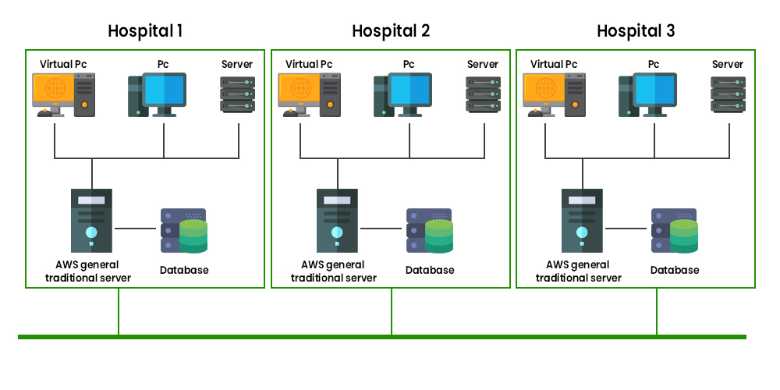

**Advantages:**

* Can solve bigger and more complex problems in a shorter time frame. Easier collaboration with other organizations and better use of existing equipment
* Existing hardware is used to the fullest.
* Collaboration with organizations made easier

**Disadvantages:**

* Grid software and standards continue to evolve
* Getting started learning curve
* Non-interactive job submission

**3. Cloud Computing**

* Provides scalable services as a utility over the Internet.
* Often built on a computer grid
* Users buy services from the cloud
  + Grid users may develop and run their own software

**B) Distributed Information Systems**

**1.Transaction Processing Systems**

* Provide a highly structured client-server approach for database applications
* Transactions are the communication model

**Obey the ACID properties**:

* **Atomic**: the transaction taking place must be indivisible for the others.
* **Consistent**: The transaction should be consistent after the transaction has been done
* **Isolated**: **:** A transaction must not interfere with another transaction
* **Durable**: committed operations can’t be undone

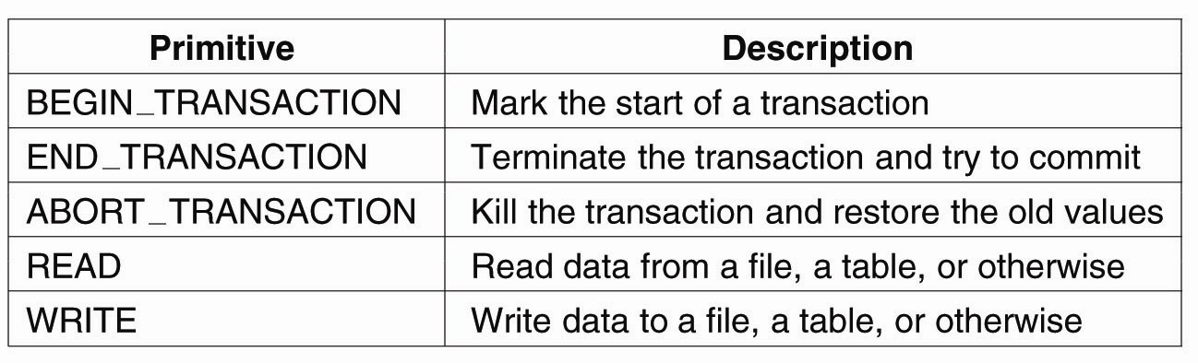

**Figure: Example primitive for transactions**

**2.Enterprise Application Integration (EAI)**

Enterprise Application Integration (EAI) is the process of bringing different businesses together. The databases and workflows associated with business applications ensure that the business uses information consistently and that changes in data done by one business application are reflected correctly in another’s. Many organizations collect different data from different plate forms in the internal systems and then they use those data are used in the Trading system /physical medium.

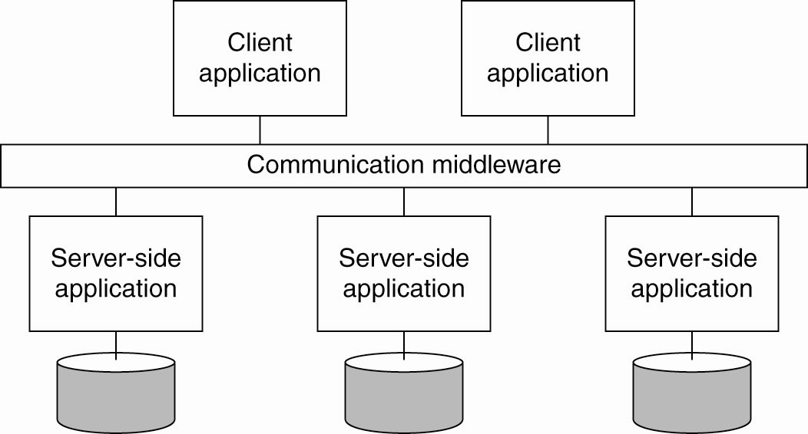

**Figure: Middleware as a communication facilitator in enterprise application integration**.

**C) Distributed Embedded Systems**

* The first two types of systems are characterized by their stability: nodes and network connections are more or less fixed
* This type of system is likely to incorporate small, battery-powered, mobile devices
  + Home systems
  + Electronic health care systems – patient monitoring
  + Sensor networks – data collection, surveillance

**Home System**

* Built around one or more PCs, but can also include other electronic devices:
  + Automatic control of lighting, sprinkler systems, alarm systems, etc.
  + Network enabled appliances
  + PDAs and smart phones, etc.

**Electronic Health Care Systems**

**Figure :Monitoring a person in a pervasive electronic health care system, using (a) a local hub or (b) a continuous wireless connection.**

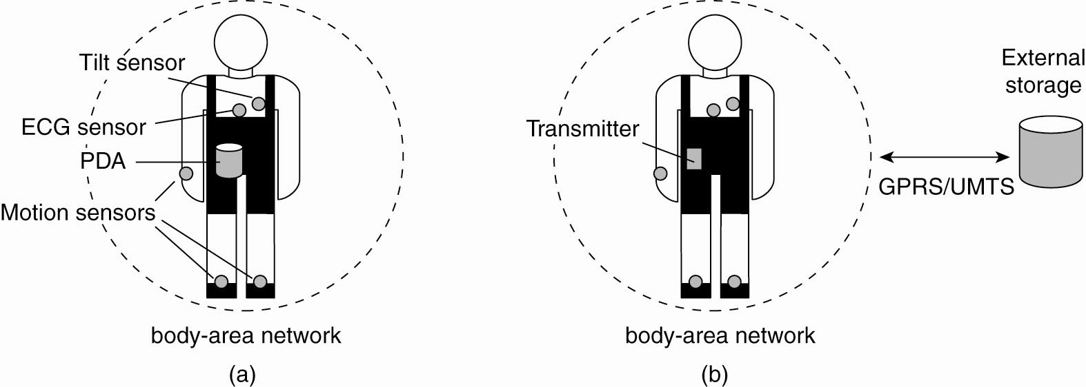

**Sensor Networks**

* A collection of geographically distributed nodes consisting of a communication device, a power source, some kind of sensor, a small processor…
* Purpose: to collectively monitor sensory data (temperature, sound, moisture etc.,) and transmit the data to a base station
* “smart environment” – the nodes may do some rudimentary processing of the data in addition to their communication responsibilities.

4) Draw the detailed flow of communication among two machines with necessary methods to establish TCP-connection and write there usage.

Ans)

TCP is a connection-oriented protocol and every connection-oriented protocol needs to establish a connection in order to reserve resources at both the communicating ends.

Connection Establishment

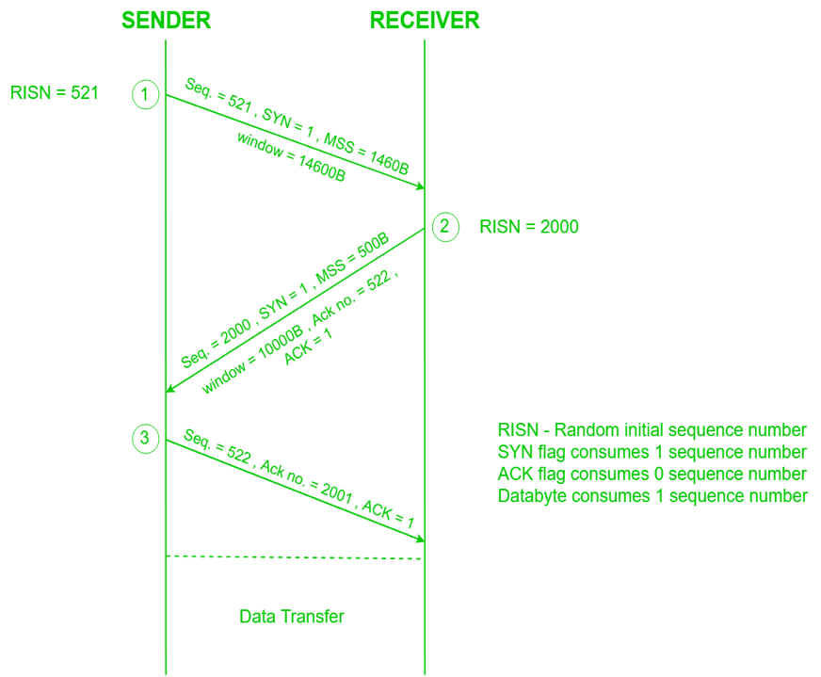

Since the connection establishment phase of TCP makes use of 3 packets, it is also known as [3-way Handshaking](https://www.geeksforgeeks.org/computer-network-tcp-3-way-handshake-process/) **(SYN, SYN + ACK, ACK).**

9)explain in detail about clock synchronization mechanisms?

Ans)

Clock synchronization is the mechanism to synchronize the time of all the computers in the distributed

environments or system.

Synchronization in distributed system is more complicated than in centralized system because of the use of distributed algorithms.

**Properties of Distributed algorithms to maintain Clock synchronization:**

* Relevant and correct information will be scattered among multiple machines.
* The processes make the decision only on local information.
* Failure of the single point in the system must be avoided.
* No common clock or the other precise global time exists.
* In the distributed systems, the time is ambiguous.

**Types of Clock Synchronization:**

* Physical clock synchronization
* Logical clock synchronization
* Mutual exclusion synchronization

**Physical Synchronization:**

* In physical clock synchronization, All the computers will have their own clocks.
* The physical clocks are needed to adjust the time of nodes. All the nodes in the system can share their local time with all other nodes in the system.
* The time will be set based on UTC (Universal Coordinate Timer).
* Physical clocks: In physical synchronization, physical clocks are used to time stamp an event on that computer.